**Practical no. -11**

**Aim:** Demonstration of various reader and writer subclasses in listing

**Program:**

import java.io.*;

public class ReaderWriter {

public static void main(String args[]) throws IOException {

System.out.println("With InputStreamReader");

int a;

String s;

InputStreamReader inr = new InputStreamReader(System.in);

System.out.print("Enter a line: ");

while ((a = inr.read()) != 13) {

System.out.print((char) a);

}

System.out.println();

System.out.println("\nWith BufferedReader and InputStreamReader");

BufferedReader br = new BufferedReader(new

InputStreamReader(System.in));

System.out.print("Enter a line: ");

String inputLine = br.readLine();

System.out.println("You entered: " + inputLine);

System.out.println("\nOutput With PrintWriter and FileWriter");

BufferedReader br1 = new BufferedReader(new InputStreamReader(System.in));

PrintWriter p = new PrintWriter(new FileWriter("Output.txt"));

System.out.print("Enter lines (Ctrl+C to exit): ");

while ((s = br1.readLine()) != null) {

p.println("Output: " + s);

}

p.close();

}

}

**Output:**

With InputStreamReader

Enter a line: Hello, Java!!

Hello, Java!!

With BufferedReader and InputStreamReader

Enter a line: Hello, Java!!

You entered: Hello, Java!!

Output With PrintWriter and FileWriter

Enter lines (Ctrl+C to exit): Hello, Java!!

**Output on file:**

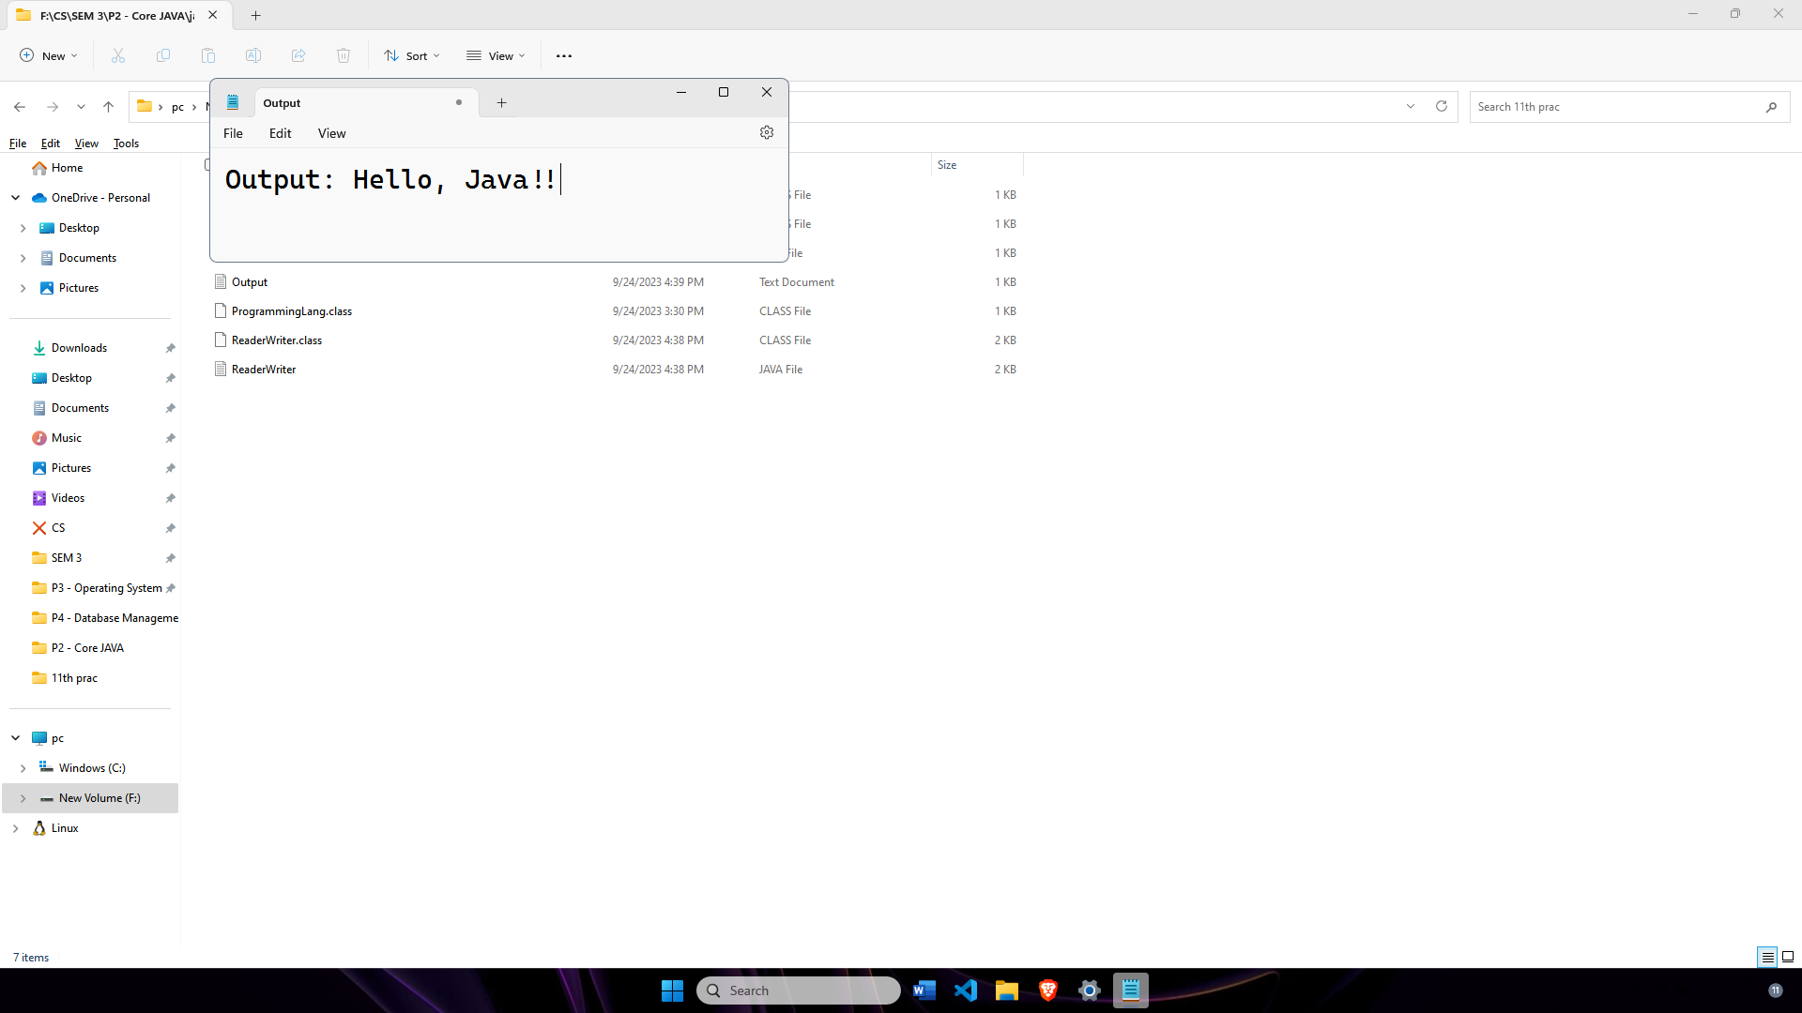

**Practical no. - 12**

**Aim :** Write a java program using runnable interface and with the help of thread class , create three threads. Run each thread 10 times and then stop thread excution.

**Program:**

class A implements Runnable {

public void run() {

int i;

for (i = 1; i <= 3; i++) {

System.out.println("Thread A : " + i);

}

}

}

class B implements Runnable {

public void run() {

int i;

for (i = 1; i <= 3; i++) {

System.out.println("Thread B : " + i);

}

}

}

class C implements Runnable {

public void run() {

int i;

for (i = 1; i <= 3; i++) {

System.out.println("Thread C : " + i);

}

}

}

class RunnableDemo {

public static void main(String hello[]) throws Exception {

System.out.println("Main starts");

Thread t1 = new Thread(new A());

Thread t2 = new Thread(new B());

Thread t3 = new Thread(new C());

t1.start();

t2.start();

t3.start();

t1.join();

t2.join();

t3.join();

System.out.println("Main ends");

}

}

**Output:**

Main starts

Thread C : 1

Thread C : 2

Thread A : 1

Thread B : 1

Thread B : 2

Thread C : 3

Thread A : 2

Thread A : 3

Thread B : 3

Main ends

**Practical no. - 13**

**Aim:** Write a program to create 4 threads to perform 4 different arithmetic operations like addition, subtraction, multiplication and division. Accept two numbers from command line arguments and perform the operations using thread.

**Program:**

import java.util.Scanner;

class Add extends Thread {

int n1, n2;

public Add(int x, int y) {

n1 = x;

n2 = y;

}

@Override

public void run() {

System.out.println("Addition is : " + (n1 + n2));

}

}

class Sub extends Thread {

int n1, n2;

public Sub(int x, int y) {

n1 = x;

n2 = y;

}

@Override

public void run() {

System.out.println("Subtraction is : " + (n1 - n2));

}

}

class Mul extends Thread {

int n1, n2;

public Mul(int x, int y) {

n1 = x;

n2 = y;

}

@Override

public void run() {

System.out.println("Multiplication is : " + (n1 * n2));

}

}

class Div extends Thread {

int n1, n2;

public Div(int x, int y) {

n1 = x;

n2 = y;

}

@Override

public void run() {

if (n2 != 0) {

System.out.println("Division is : " + (n1 / n2));

} else {

System.out.println("Division by zero is not allowed.");

}

}

}

class ThreadDemo {

public static void main(String ar[]) {

try {

Scanner scanner = new Scanner(System.in);

System.out.print("Enter 1st number: ");

int a = scanner.nextInt();

System.out.print("Enter 2nd number: ");

int b = scanner.nextInt();

new Add(a, b).start();

new Sub(a, b).start();

new Mul(a, b).start();

new Div(a, b).start();

} catch (Exception e) {

System.err.println("An error occurred: " + e.getMessage());

}

}

}

**Output:**

Enter 1st number: 4

Enter 2nd number: 5

Subtraction is : -1

Division is : 0

Addition is : 9

Multiplication is : 20

**Practical no. – 14**

**Aim:** Write a client socket that will accept n names from user and send them to the server. After receiving the names , the server socket should send the message “names received: and close the connection.

**Program:**

**Server code:**

import java.io.*;

import java.net.*;

public class Server {

public static void main(String[] args) {

final int port = 12345;

try {

ServerSocket serverSocket = new ServerSocket(port);

System.out.println("Server is listening on port " + port);

while (true) {

Socket clientSocket = serverSocket.accept();

System.out.println("Client connected: " + clientSocket.getInetAddress());

BufferedReader reader = new BufferedReader(new InputStreamReader(clientSocket.getInputStream()));

PrintWriter writer = new PrintWriter(clientSocket.getOutputStream(), true);

String receivedNames = reader.readLine();

System.out.println("Received names from client: " + receivedNames);

writer.println("NAMES RECEIVED: " + receivedNames);

writer.close();

reader.close();

clientSocket.close();

}

} catch (IOException e) {

e.printStackTrace();

}

}

}

**Client code:**

import java.io.*;

import java.net.*;

import java.util.Scanner;

public class Client {

public static void main(String[] args) {

final String serverAddress = "localhost";

final int serverPort = 12345;

try {

Socket socket = new Socket(serverAddress, serverPort);

System.out.println("Connected to server: " + serverAddress + ":" + serverPort);

BufferedReader reader = new BufferedReader(new InputStreamReader(socket.getInputStream()));

PrintWriter writer = new PrintWriter(socket.getOutputStream(), true);

Scanner scanner = new Scanner(System.in);

System.out.print("Enter names (separated by commas): ");

String names = scanner.nextLine();

writer.println(names);

String confirmationMessage = reader.readLine();

System.out.println("Server says: " + confirmationMessage);

socket.close();

reader.close();

writer.close();

} catch (IOException e) {

e.printStackTrace();

}

}

}

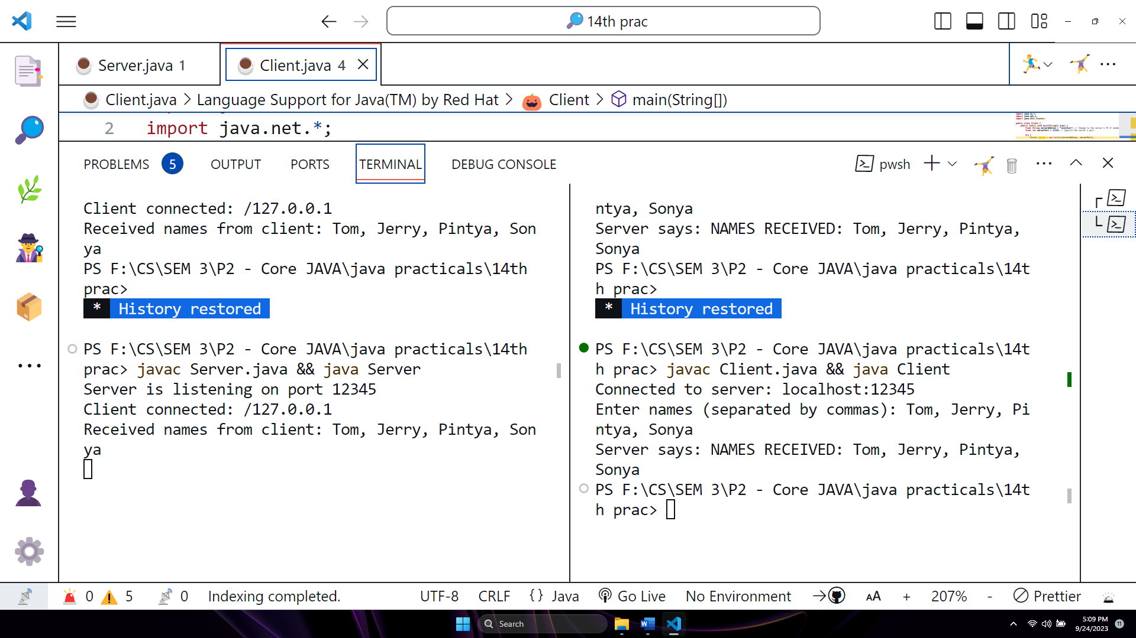

**Output:**

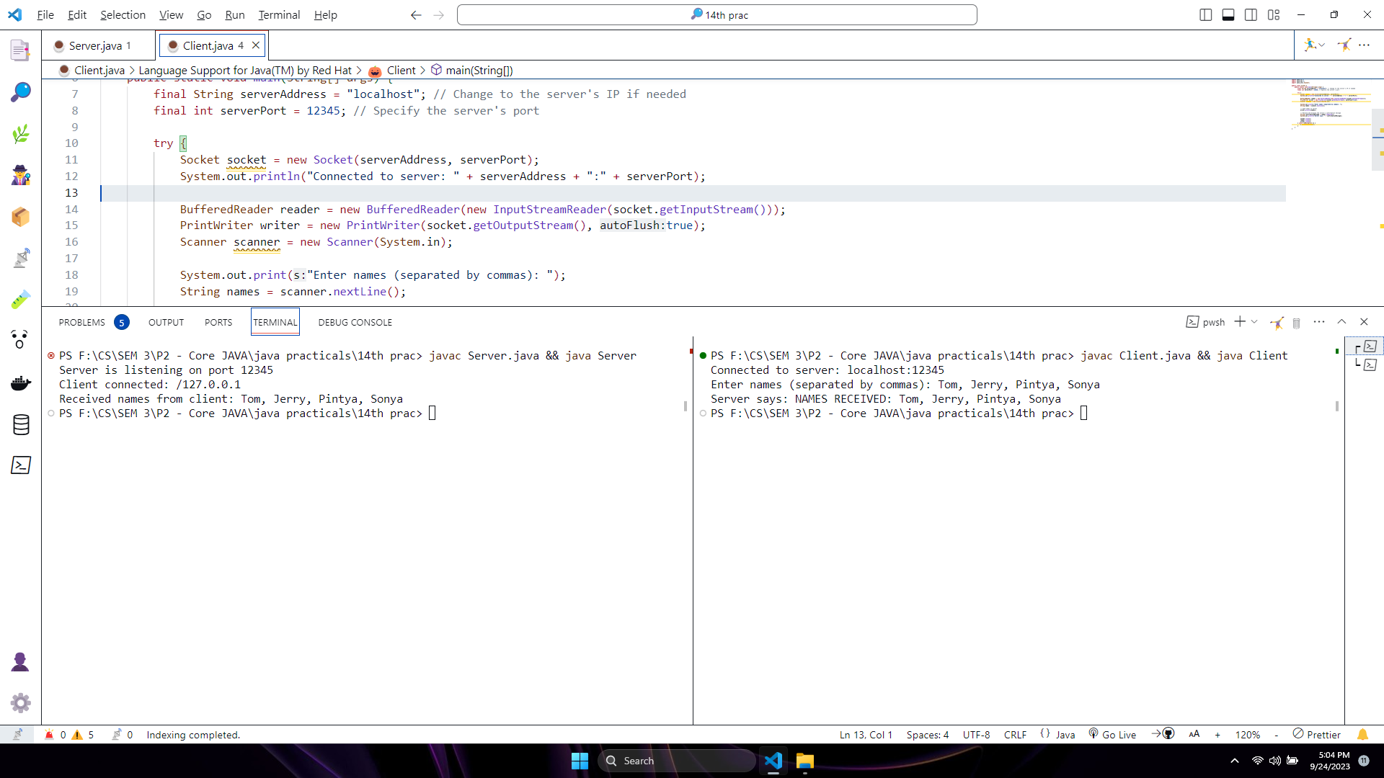**Server Output:**

**Client Output:**

**Practical no. 15**

**Aim:** Create a client socket which sends a number to the server. The server socket returns the sum of digits of the number if the number is positive, otherwise it sends an error message and close the connection.

**Program:**

**Server code:**

import java.io.*;

import java.net.*;

public class Server {

public static void main(String[] args) {

final int port = 12345;

try {

ServerSocket serverSocket = new ServerSocket(port);

System.out.println("Server is listening on port " + port);

while (true) {

Socket clientSocket = serverSocket.accept();

System.out.println("Client connected: " + clientSocket.getInetAddress());

BufferedReader reader = new BufferedReader(new InputStreamReader(clientSocket.getInputStream()));

PrintWriter writer = new PrintWriter(clientSocket.getOutputStream(), true);

String clientInput = reader.readLine();

try {

int number = Integer.parseInt(clientInput);

System.out.println("Received number from client: " + number);

if (number >= 0) {

int sumOfDigits = calculateSumOfDigits(number);

writer.println("Sum of digits: " + sumOfDigits);

} else {

writer.println("Error: Negative number not allowed");

}

} catch (NumberFormatException e) {

writer.println("Error: Invalid input");

}

writer.close();

reader.close();

clientSocket.close();

}

} catch (IOException e) {

e.printStackTrace();

}

}

private static int calculateSumOfDigits(int number) {

int sum = 0;

while (number != 0) {

sum += number % 10;

number /= 10;

}

return sum;

}

}

**Client code:**

import java.io.*;

import java.net.*;

import java.util.Scanner;

public class Client {

public static void main(String[] args) {

final String serverAddress = "localhost";

final int serverPort = 12345;

try {

Socket socket = new Socket(serverAddress, serverPort);

System.out.println("Connected to server: " + serverAddress + ":" + serverPort);

BufferedReader reader = new BufferedReader(new InputStreamReader(socket.getInputStream()));

PrintWriter writer = new PrintWriter(socket.getOutputStream(), true);

Scanner scanner = new Scanner(System.in);

System.out.print("Enter a number: ");

String input = scanner.nextLine();

writer.println(input);

String serverResponse = reader.readLine();

System.out.println("Server says: " + serverResponse);

socket.close();

reader.close();

writer.close();

} catch (IOException e) {

e.printStackTrace();

}

}

}

**Output:**

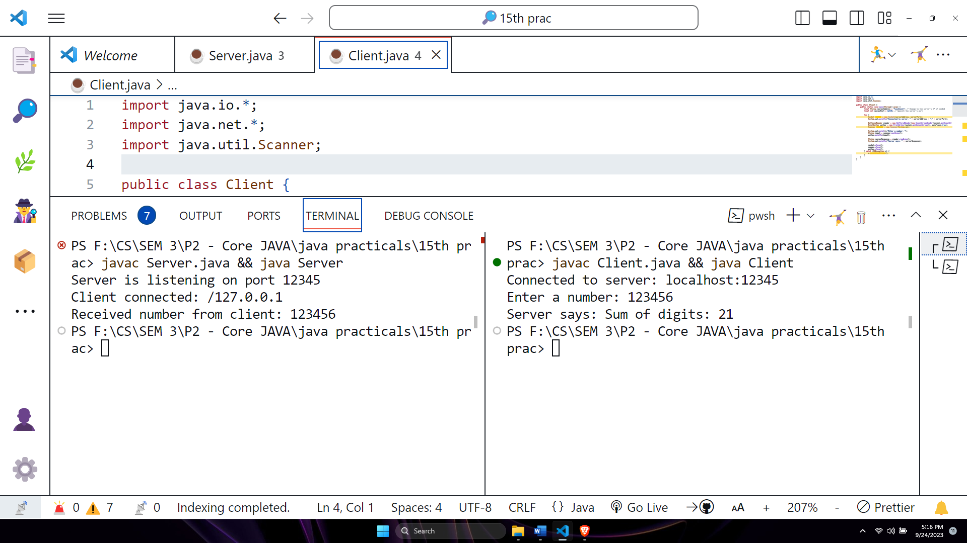

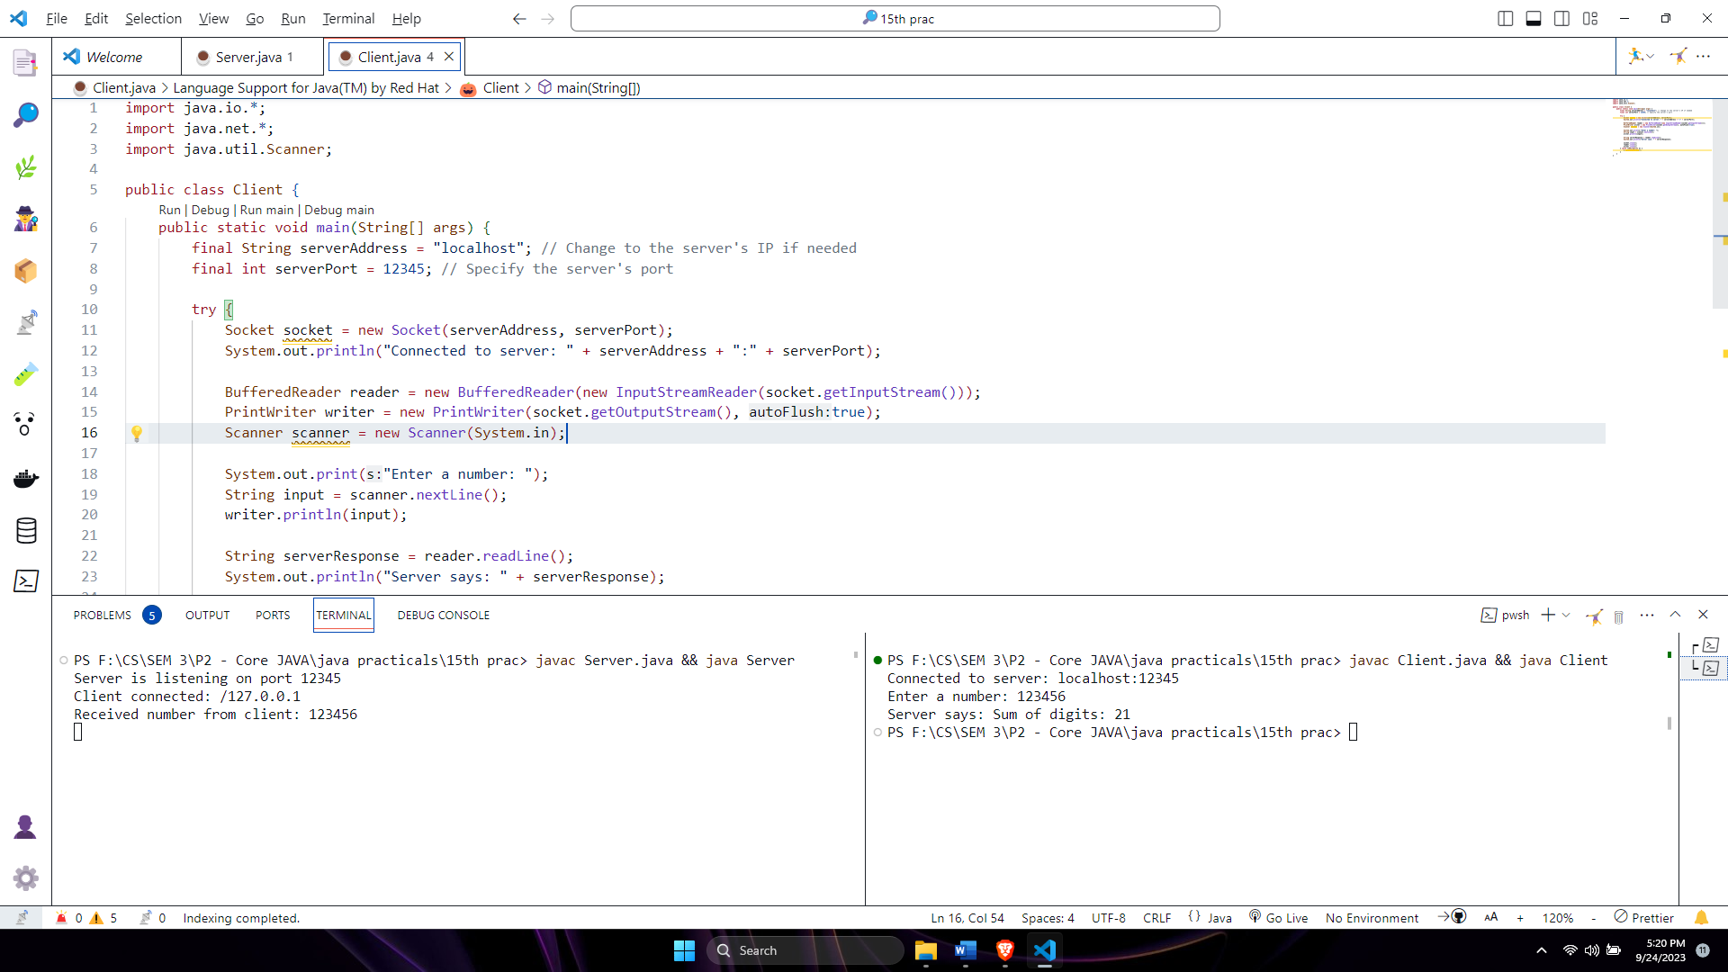**Server output:**

**Client output:**